Welding Program Tool List

Welding equipment and supply stores
Most supply stores will offer a student discount with I.D.

Central Welding Supply*
*preferred for consumable purchases, the BTC Welding Department works directly with Central Welding Supply to guarantee that students are purchasing the correct consumables

4282 Pacific Hwy
(360) 714-9353

Cascade Airgas
401 Kansas Street
(360) 734-4980

Linde Welding
430 Ohio Street - Suite A
(360) 733-0970

Personal Protective Equipment (PPE) and Miscellaneous
- Natural fiber work clothing (EX. Cotton or Wool) ((No fleece or polyester!))
- Welding Hood (shade 10-13, fixed or auto darkening*
*Auto darkening hoods are great for learning because students can see the work before they start welding. Auto darkening hoods that students purchase should be industry quality where batteries, front lens covers, and inside lens covers can be replaced.
- Inner and outer cover lens for your welding hood (10 pack)
- Leather welding gloves
- Lightweight Cotton Flame Resistant Welding Jacket
- Leather welding jacket or sleeves
- Steel/Safety toe leather work boots
- Hearing protection (ear plugs or ear muffs, will be needed every day in shop)
- (2 qty) ANSI (Z87 Rated) safety glasses, CLEAR
- Z87 clear grind face shield and head gear for grinding
- Shade 5 face shield with head gear for thermal cutting (weld hoods with shade 5 setting may be used instead)
- Knee pads or a kneeling pad
- Half mask welding respirator, recommended 3M Half Mask Respirator/P100 cartridges (pink)
- Pad Lock (For personal tool lockers)
- Tool bag that will fit in locker, (half size locker)
- Tackle box for small parts

General Tools
*pictures are not to scale
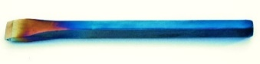
- Cold Chisel ½” x 6”

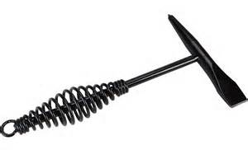
- Chipping hammer

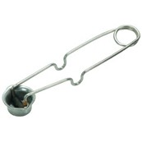
- Striker for oxy-fuel cutting

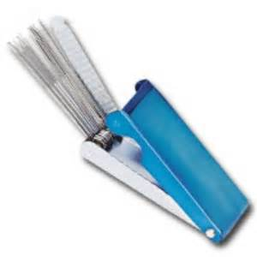
- Tip cleaners

- Wire Cutters aka “Welpers” (Welder’s Helpers)
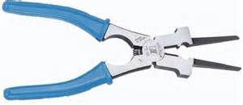

- 4 ½” Angle Grinder, with unmodified guard, handle and paddle switch, corded (not battery powered)

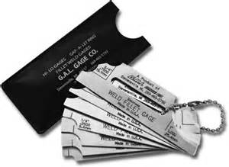
- Standard Fillet Weld Gauge (metal construction)

- Half round flat file, 12”- 16”
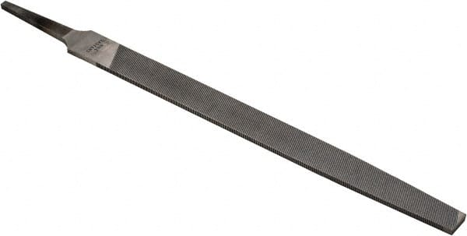

Fabrication Tools
- Soapstone and holder or Silver Pencil
- Paint pens or white outs pen for marking name on projects
- Permanent Marker
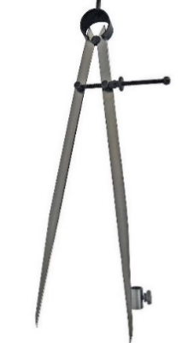
- 12” Steel Layout compass

- Tape Measures (SAE and Metric)

- Combination Square (All metal construction to avoid melting)

- 4lb (64oz) Engineering Hammer
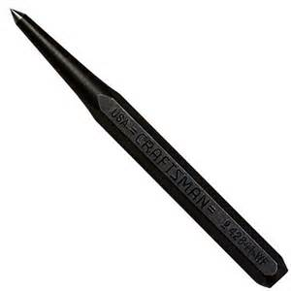
- Center punch ½” x 5-1/2”

- One Vise Clamp and One Bessy clamp
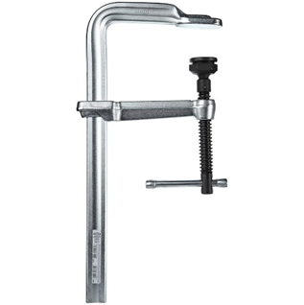
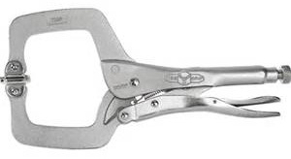

Fall Quarter: Required Consumables
*consumables are items that are “used up” or “consumed” during welding work, students will need to replace items as they wear out and be prepared to buy multiples of each item. The quantity listed below is a good starting point for each quarter. The BTC Welding Department does not supply consumables to students.
GMAW:
- (5 qty) Nozzle 24A-62 (for Tweco #4 Gun)
- (5) Insulator 34A (for Tweco #4 Gun)
- (10) Contact Tips .035 (for Tweco #4 Gun)
General Fabrication:
- (2 qty) 2-1/2” stainless steel wire brushes
- (4) 4 1/2" X 1/4” grinding discs for use on mild steel, not threaded
- (4) 4 1/2" X 1/8” grinding discs for use on mild steel (not cutting discs, not threaded)
- (4) 4 ½” X 7/8” Flap or sanding discs for use on mild steel, not threaded
- (2) 4” x 5/8”- Steel knotted/braided wire wheel
Winter Quarter: Required Consumables
FCAW:
- (10 qty) .045 Tip, Contact 14-45 TWECO (TWE 1140-1104)
- (5) Nozzle 24A-62 (for Tweco #4 Gun)
- (5) Insulator 34A (for Tweco #4 Gun)
- (2) Diffuser, 54A TWECO (TWE 1540-1100)

GTAW Steel:
- (2 qty) Heat Shield, Standard (CK 598882)
- (1) Collet Body, 1/16” 2CB116 (CK 13N27)
- (1) Collet Body, 3/32” 2C332 (CK 13N23)
- (2+) Collet, 1/16” 2C116 (CK 13N22)
- (2+) Collet, 3/32” 2C332 (CK 13N23)
- (1) Cup 2A5 (CK 13N09)
- (1) Cup 2A7 (CK 13N11)
- (3+) Tungsten, 2% Lanthanated 1/16” X 7” Quantity: 3 or more
- (3+) Tungsten, 2% Lanthanated 3/32” X 7” Quantity: 3 or more
- (1) Back Cap, Long 41V24
- Leather TIG or lightweight MIG Gloves

General Fabrication:
- (4 qty) 4 1/2" X 1/4” Grinding discs, not threaded
- (4) 4 1/2" X 1/8” Grinding discs (not cutting discs, not threaded)
- (4) 4 ½” X 7/8” flap or sanding disc for use on mild steel, not threaded
- (2) 2-1/2” Stainless steel wire brushes
- (2) 4” x 5/8”- Steel knotted/braided wire wheel

Blueprint Reading
- 8 ½” X 11” and 11” X 17” graph paper (with standard measurements)
- Drawing compass
- Protractor
- 45/45/90 drafting triangle, and 30/60/90 drafting triangle
- Straight edge
- Mechanical pencils and erasers
- Blueprint Reading for Welders (9th edition, available in college book store)

Spring Quarter: Required Consumables
FCAW:
- (2 qty) Diffuser, 54A TWECO (TWE 1540-1100)
- (2) Insulator, 34A TWECO (TWE 1340-1100)
- (1) Nozzle, 24A62 TWECO (TWE 1240-1120)
- (10) .045 Tip, Contact 14-45 TWECO (TWE 1140-1104)
General Fabrication:
- (1 qty) 4 ½” stainless steel wire wheel
- (2) 2-1/2” stainless steel wire brushes
- (1) 4 ½” flap/ sanding disc (for aluminum, not threaded)
- (1) 4 ½” x 1/4” grinding disc for use on aluminum, not threaded
- New MIG and TIG welding gloves for use on aluminum only

Aluminum GTAW:
For MASTER TIG CK230 RG TIG TORCH:
- (1 qty) Insulators
- (1) 1/8” SERIES 2 GAS LENS
- (1) #7 TIG CUP
- (1) 1/8” COLLETS
- (1) Back CAP, LONG 41V24
- (3+) Tungsten electrode 2% lanthanated, 1/8” diameter.

